**Year 7 Biology Research Assignment Validation Test Name: _______________________**

**Instructions:** Write your answers in the spaces provided

**Your selected ecosystem biome**: __________________________

1. Where is your biome located? Shade in the areas on the world map: (2 marks)

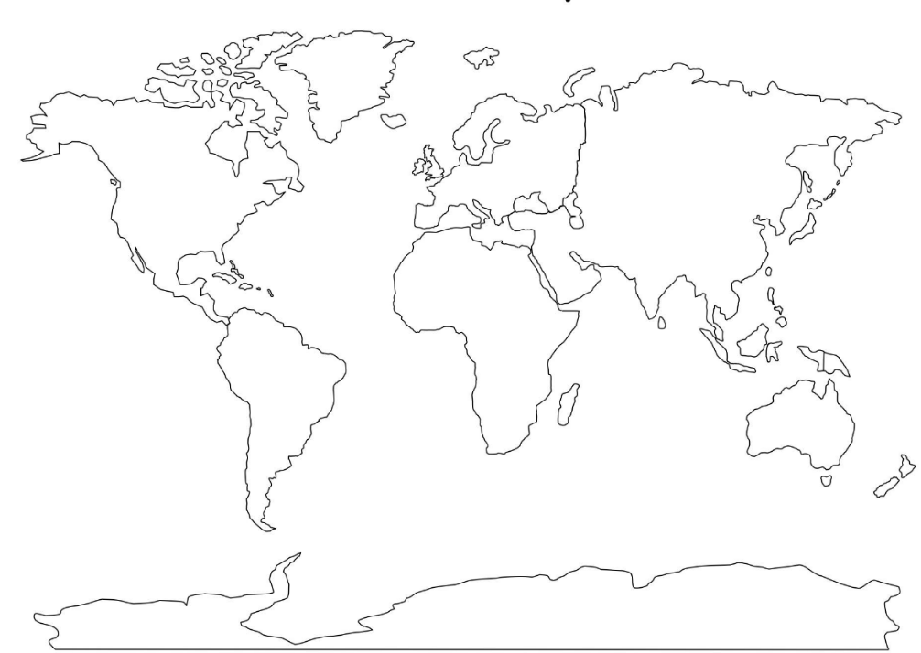

1. Draw a food chain for your biome with at least 4 living things: (2 marks)

Please turn over

1. Draw a food web for your biome with at least 5 living things: (3 marks)
2. How has humans influenced your biome?
3. Positive: __________________________________________________________________

_________________________________________________________________________

_________________________________________________________________________

(1 mark)

1. Negative: _________________________________________________________________

_________________________________________________________________________

_________________________________________________________________________

_________________________________________________________________________

_________________________________________________________________________

_________________________________________________________________________

(2 marks)

**END OF TEST MARKS: _______ / 10 marks**